Hello Residents,
We are thrilled to announce that bulk DIRECTV STREAM service will soon be available to your community. This means that homeowners will have access to a wide range of live TV channels, premium content, and on-demand options all in one place. You now can watch your favorite shows on your phone, tablet, and other devices PLUS the DIRECTV Gemini device.
DIRECTV STREAM Features
- Simple, straightforward live TV - Fully customizable channel guide for easy surfing. Turn on the device and immediately tune into the last channel you were watching.
- Premium, full-featured voice remote - Not just a numbered keypad - you can talk to it, too. Use Google Assistant to change channels, search for content & more. The Gemini device switches channels quickly and delivers crystal-clear live-streaming TV.
- Live TV & On-Demand all in one place - Access 7,000+ apps from the Google Play store, right alongside your live TV & DVR recordings.
Your DIRECTV ULTIMATE Package Includes
- Over 185 channels of live TV, including sports, news, and local programming
- Max Bundle which includes HBO, Cinemax and the MAX app
- Local and Regional Sports Network channels included
- On-demand access to thousands of movies and TV shows
- Two (2) DIRECTV STREAM Gemini devices are easy to self-install
- A full-featured voice remote with each Gemini devices, so you can access your favorite content
- The ability to stream content on 20 devices in-home, 3 out-of-home
- DIRECTV App so you can watch your TV anytime, anywhere
- Unlimited Cloud DVR included at no additional cost
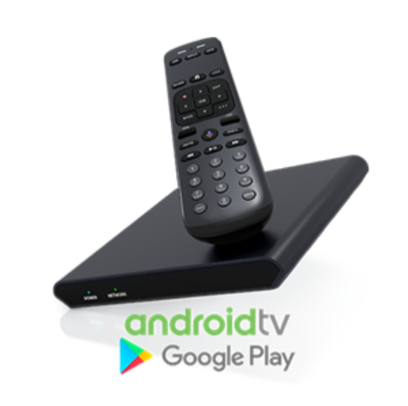
The Gemini and it's Remote Provide the Best TV Experience
- Fully integrated TV experience:
  - Switch between live, recorded and On-Demand TV while having access to some of your favorite apps like Max, Netflix, and Amazon Prime Video*.
    - *Separate subscription required.
  - All with just one device! No need to switch inputs!
- Familiar remote buttons made for watching TV:
  - Number keypad, Channel & Volume Up/Down control, Pause, Fast Forward, Rewind, Record, and Previous Channel.
- Intuitive One-Click Commands:
  - Access the Channel Guide, cDVR Library, Apps, and the Google Assistant with the push of a button on your Gemini remote.
- Google Assistant Voice Control: Control your TV and smart home devices with Google Assistant.

Speak, Watch, Pause, and Do More with Your TV Remote
- Use the Google Assistant to watch what you love and control it with your voice.
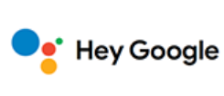
- No additional device needed!
- A Google login is required to personalize your TV experience.
- A Google Account is different from the DIRECTV STREAM ID.
- A Google Account is free!

See table below for Google Assistant features with or without a Google Account

Standard Google Features | Features Requiring  a Google Account
No Google sign-in required. | Sign-in with your Google Account or create a new one.
Voice remote powered by the Google Assistant  - DIRECTV STREAM Voice Navigation (channel tuning, open apps, closed captioning)  - Record shows and sports team games  - Universal content searches by title, genre or actor – with DIRECTV STREAM results prioritized  Chromecast  - Cast content from a mobile device or computer to your home's big screen | Voice remote powered by the Google Assistant  - Pull up your personal photos or calendar  - Manage third-party home devices (example: interior lights)  - Link third-party accounts for placing orders  Download Apps  - Browse 5000+ apps & games  App Purchases  - Bring previously purchased Android Apps with you from other devices, and make new purchases  Saved Passwords  - Login ID/Passwords remembered for 3rd party apps like Netflix

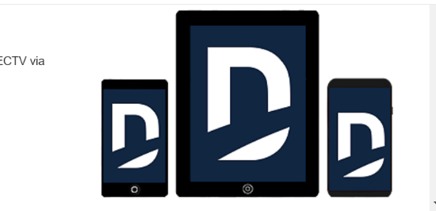
Start Streaming Immediately with the DIRECTV App
Start Streaming Immediately: There's no reason to delay while waiting for your Gemini devices, you can start enjoying immediately after activation using your phone, tablet, or other compatible device using the DIRECTV app.
Immediate Access to Shows and Movies You Love
- Guide to make searching easy
- DVR scheduler/Cloud DVR
  - Use your device to record TV shows and movies
  - Manage recorded programming in My Library
Watch Anytime, Anywhere
- Browse what's on now and schedule your DVR even when away from home.
- Take your television (TV) on the go: Customers can also use Amazon FireTV, Apple TV, Roku devices, and Android TV prior to installation, or on the move.
- Local channels and Regional Sports Network (RSN) availability varies by market, blackouts may apply.
  - For a complete list of compatible devices please visit https://www.directv.com/support/stream/article/000066174
Preparing for DIRECTV STREAM
- Check your Email address: You will need to use a different email address that isn’t currently or has been associated with an AT&T/DIRECTV account.
  - For the full experience of the Gemini device and remote, we recommend using a Google Account. This is required to take advantage of the full features of the Google Assistant. You can create a Google Account by following the instructions here. (URL: https://support.google.com/accounts/answer/27441?hl=en)
  - For more information on Google Assistant please visit Google Assistant
- Review Attached Included Channel Lineups*
  - Favorite channel or premium not included? You can easily upgrade at the time of account creation with our resident upgrade options.
    - Premier 150+ live channels plus 80,000 on-demand titles
      - Ultimate to Premier $55 per month
  - Premium Programming channels (ala carte)
    - Paramount + Showtime- $11.99
    - Starz $10.99
    - Epix $6
    - Movie Extra Pack $5
  - Espanol & International $5-$30
  - Additional DIRECTV STREAM devices
    - $120 each or payment plan through Affirm
- *prices or programming subject to change at anytime

Launch Expectations
Live Date: Once the property is ready to launch with DIRECTV STREAM bulk services, you will receive an additional communication. This communication will have the customized website link with a step-by-step guide on how to create your bulk DIRECTV account and order Gemini devices. It takes about 5 minutes to complete initial sign up and your new Gemini devices will be delivered directly to your home or specified shipping address in 2-3 business days.
Next Steps
More information will be coming to you in the upcoming days along with dedicated call center phone number. We look forward to working with you and helping you transition to DIRECTV STREAM!

